MINI-PROJECT 1

Enterprise Student Record and
Academic Management Platform
Design Thinking and Product Planning

Student Name: Suraj Ganesh Sase
Programme / Branch: B.Tech — Artificial Intelligence and Data Science
Year / Semester: 2nd year, 3rd sem
College: Sanjivani University
Course / Trainer: karan Gaikwaad sir
Submission Date:19/08/2026

Important note before submission
Two supplied source documents describe different project domains. The Unit-1 Mini Project brief names the Enterprise Student Record and Academic Management Platform. The separate technical guide describes a Library Management Platform. This document follows the Student Record brief because that is the title and objective of the dedicated Unit-1 mini-project brief. Confirm the intended topic with the trainer before submitting. Do not submit this draft unchanged if the trainer confirms the Library Management Platform instead.
This file is a drafted report, not proof that all activities have already been performed. Replace placeholders, validate proposed requirements with your trainer or intended users, and add genuine screenshots/evidence for repository and practical work.

Contents
- 1. Executive Summary
- 2. Business Understanding and Problem Statement
- 3. Design Thinking Report
- 4. IBM Design Thinking and IBM Loop
- 5. Stakeholder Analysis
- 6. User Personas
- 7. Business Requirements Document (BRD)
- 8. Functional Requirements Specification (FRS)
- 9. Non-Functional Requirements Specification (NFRS)
- 10. Product Vision and Success Criteria
- 11. Minimum Viable Product (MVP)
- 12. Product Roadmap
- 13. Initial System Architecture
- 14. Project Charter and Milestones
- 15. Repository Structure and Git Evidence
- 16. Product Discovery Documentation
- 17. Requirement Coverage Checklist
- 18. Viva / Interview Preparation
- 19. Final Submission Checklist

1. Executive Summary
The Enterprise Student Record and Academic Management Platform is a proposed software solution for organizing student information and academic processes in a higher-education institution. The initial scope focuses on student registration, academic record management, attendance tracking, examination/result records, and report generation. The purpose of Unit 1 is to understand the users and their problems before starting implementation.
The project applies the five Design Thinking stages—Empathize, Define, Ideate, Prototype, and Test—along with IBM Design Thinking principles and the Observe → Reflect → Make loop. The outputs are intended to guide later Agile planning and development.

2. Business Understanding and Problem Statement

2.1 Domain overview
Academic administration commonly involves student admission, course registration, attendance recording, examinations, result preparation, and academic reporting. If these activities rely on disconnected spreadsheets or paper records, staff may need to enter the same information multiple times, locating records may take longer, and producing consistent reports can become difficult. These are problem hypotheses to validate with actual users, not measured findings from a completed field study.

2.2 Problem statement
Students, faculty members, and academic administrators need a reliable way to maintain and retrieve student and academic records. When information is stored across manual or disconnected systems, updating records, tracking attendance, preparing results, and generating reports may require extra effort and can introduce inconsistencies. The proposed platform aims to centralize the core records and make routine academic workflows clearer and more consistent.

2.3 Business objectives
- Provide a consistent record for each registered student.
- Support course and academic record management.
- Allow authorized faculty to record and review attendance.
- Support entry and retrieval of examination and result information.
- Generate useful academic reports for authorized users.
- Protect student information through role-based access and controlled handling.

2.4 Assumptions and items to validate
Item | Current working assumption | How to validate
Users | Students, faculty, academic administrators, examination staff, IT support. | Confirm user groups with the trainer or institution.
Current process | Some records may be manual or spread across tools. | Ask staff how records are currently maintained.
Access | Different roles should have different permissions. | Confirm who can view, add, edit, and approve each record.
Data | Student and academic information is sensitive. | Confirm institutional data-handling rules.
Scope | Initial release includes registration, records, attendance, reports. | Confirm the required MVP scope.

3. Design Thinking Report
Design Thinking is a human-centered approach. It starts by understanding users, then defines the problem, explores solutions, builds a simple prototype, and tests it before committing to a full implementation. The stages can repeat when feedback reveals a better direction.
Stage | Activity for this project | Expected output
Empathize | Talk with or observe students, faculty, and academic staff. Ask how they register students, record attendance, manage results, and prepare reports. | Notes about user tasks, pain points, and needs. Do not claim interviews were conducted unless they were.
Define | Group the observations and write a focused problem statement. | Problem statement and list of user needs.
Ideate | Brainstorm possible solutions, then compare them by value, effort, and risk. | Prioritized solution ideas.
Prototype | Sketch simple screens for student registration, attendance entry, result entry, and report viewing. | Paper sketches or wireframes.
Test | Ask representative users to complete sample tasks using the prototype and record where they struggle. | Feedback, issues, and revised design.

3.1 Example interview questions
- What student information do you need most often?
- How do you currently record or check attendance?
- What makes result preparation or report generation difficult?
- Who should be allowed to edit student records?
- What errors happen most often, and how are they corrected?
- What would make the proposed system easy to use?

3.2 Prototype screens to prepare
Screen | Main elements | Purpose
Student registration | Student ID, name, programme, semester, contact fields, save/cancel. | Create a consistent student record.
Student profile | Student details, course/semester, academic history. | View relevant records in one place.
Attendance entry | Course, date, student list, present/absent status, save. | Record attendance for a class.
Result entry | Course, assessment, marks/grade, validation, submit. | Enter and review examination results.
Academic reports | Filters for programme, semester, course, and date range. | Generate reports for authorized users.

Evidence to add: insert screenshots or images of your own sketches/wireframes after creating them.

4. IBM Design Thinking and IBM Loop

4.1 Three principles
Principle | Meaning | Application
Focus on User Outcomes | Measure whether the system improves a real user task, not only whether a feature exists. | For example, test whether authorized staff can find a student's record with fewer steps.
Restless Reinvention | Use feedback and evidence to keep improving the solution. | Revise the attendance workflow after observing users try the prototype.
Diverse Empowered Teams | Include people with different responsibilities and perspectives. | Consider students, faculty, academic administrators, examination staff, and IT support.

4.2 Observe → Reflect → Make
Loop step | What happens | Project example
Observe | Collect evidence from user activities, feedback, and system behavior. | Notice which fields staff search for most often or where users get confused.
Reflect | Discuss what the evidence means and choose the most important problem. | Decide whether the registration form needs fewer fields or clearer validation.
Make | Build or change a small part of the solution and test it again. | Update the wireframe, then ask a user to try the task again.

This loop is continuous. A team can return to Observe after making a change to check whether the change helped.

5. Stakeholder Analysis
Stakeholder | Needs / expectations | Responsibilities or influence
Students | Correct personal details, access to relevant academic information, understandable status updates. | Provide feedback on student-facing tasks and verify their own records.
Faculty members | Simple attendance entry and access to relevant class lists. | Maintain attendance and submit academic information according to policy.
Academic administrators | Consistent student records and efficient administrative workflows. | Define process rules and validate record-management requirements.
Examination cell staff | Accurate result records and controlled report generation. | Manage examination-related workflows and verify results.
IT support | Maintainable system, secure access, backups, and troubleshooting information. | Support access, availability, security, and operations.
College management | Reliable reporting and compliance with institutional policies. | Approve objectives, priorities, and resources.

5.1 Stakeholder communication plan
Stakeholder group | Engagement method | Timing
Students and faculty | Short interview or feedback session; prototype task test. | During discovery and prototype testing.
Academic/examination staff | Workflow walkthrough and requirements review. | Before finalizing requirements.
IT support | Review access, security, backup, and deployment considerations. | During architecture and planning.
Trainer / project evaluator | Review scope and required deliverables. | At Unit 1 checkpoints.

6. User Persona Report
The following are draft personas for planning. They are representative examples, not real interview participants.
Persona | Goals | Challenges / pain points | Potential platform support
Aarav — Student | Keep personal details correct and check academic information. | May not know which office to contact or whether a record has been updated. | Student profile and clear record/status views, subject to permissions.
Ms. Patil — Faculty member | Record attendance accurately and access class information quickly. | Repeated manual entry and correcting mistakes can consume time. | Attendance entry with validation and review.
Mr. Sharma — Academic administrator | Maintain student records and prepare dependable reports. | Duplicate records and inconsistent formats can make reporting harder. | Centralized records and filtered report generation.
Ms. Deshmukh — Examination staff | Enter and verify results with appropriate controls. | Result corrections require care and an audit trail. | Controlled result entry and authorized report access.

Replace or refine these personas after gathering feedback from real users, where possible.

7. Business Requirements Document (BRD)

7.1 Business need
The institution needs a consistent and controlled approach to managing student and academic information. The proposed platform should reduce avoidable duplication, make routine record retrieval easier, and support accurate academic reporting.

7.2 Scope
In scope for the proposed MVP | Not included unless separately approved
Student registration and basic student record management. | Fee payments, payroll, hostel management, transport management.
Course/semester association where required. | Integration with external government or university systems.
Attendance recording. | Biometric attendance hardware.
Examination/result record entry and retrieval. | Automated exam proctoring.
Basic academic report generation. | Predictive analytics or AI-based student risk scoring.

7.3 Business constraints
- Only authorized users should access personal and academic records.
- Required fields and validation rules must be agreed before implementation.
- Any use of real student data must follow institutional approval and applicable privacy/security rules.
- Features beyond the agreed MVP should be prioritized separately.

8. Functional Requirements Specification (FRS)
ID | Requirement | Priority | Acceptance check
FR-01 | The system shall allow an authorized administrator to register a student with required fields. | Must | A valid record can be saved; missing required fields are identified.
FR-02 | The system shall allow authorized users to view and update permitted student details. | Must | A permitted update is saved and shown when the record is reopened.
FR-03 | The system shall associate students with the relevant course/programme/semester information as defined by the institution. | Must | The correct association is displayed for a sample student.
FR-04 | The system shall allow authorized faculty to record attendance for a course and date. | Must | Attendance can be saved and retrieved for the selected class/date.
FR-05 | The system shall allow authorized examination staff to enter and review result information. | Must | A result entry is stored and can be retrieved by an authorized user.
FR-06 | The system shall generate basic academic reports using approved filters. | Must | A report returns records matching the chosen filter.
FR-07 | The system shall restrict functions according to user roles. | Must | A user without the required role cannot access a restricted action.
FR-08 | The system should support searching for a student using an approved identifier. | Should | A valid identifier retrieves the matching record.

These are proposed requirements derived from the brief's examples. Confirm exact field names, roles, and rules before implementation.

9. Non-Functional Requirements Specification (NFRS)
ID | Quality area | Proposed requirement / design target | How to verify
NFR-01 | Security | Access to personal and academic data must be restricted by role. | Test permitted and denied actions for each role.
NFR-02 | Usability | Common tasks should use clear labels, validation messages, and consistent navigation. | Ask representative users to complete defined tasks and record confusion.
NFR-03 | Reliability | Saved records should remain consistent when viewed again; invalid data should be rejected. | Run create/read/update and invalid-input tests.
NFR-04 | Scalability | The architecture should allow future growth in users and records without requiring a complete redesign. | Document expected growth and review architecture choices.
NFR-05 | Maintainability | Code, configuration, documentation, and tests should be organized and version-controlled. | Review repository structure and change history.
NFR-06 | Backup and recovery | A backup and recovery approach should be defined before using important data. | Document and test a recovery procedure in a safe environment.

Numerical targets such as response time, availability, and concurrent users are not specified in the Student Record brief. Agree measurable targets with the trainer before treating them as mandatory.

10. Product Vision and Success Criteria

10.1 Vision statement
To provide a reliable and easy-to-use academic information platform that helps authorized students, faculty members, and administrators manage student records, attendance, results, and academic reports in a consistent way.

10.2 Mission statement
Design and incrementally develop a secure, maintainable platform that organizes core academic records and supports routine institutional workflows, using user feedback to improve the product over time.

10.3 Business objectives and success criteria
Objective | Possible measure | Measurement note
Improve record retrieval | Time taken to find a sample student record. | Record a baseline and compare after a prototype or implementation.
Reduce avoidable data errors | Number of validation errors or duplicate records in a defined test set. | Define the test set and error categories first.
Support attendance workflow | Percentage of test attendance entries saved correctly. | Use sample data, not real personal records.
Support report generation | Whether reports match a manually verified sample. | Verify calculations and filters against expected results.
Protect data | Results of role-permission tests. | Test both allowed and blocked actions.

11. Minimum Viable Product (MVP)
The MVP is the smallest useful first release that tests the core value of the product.
MVP feature | Included behavior | Deferred / excluded for first release
Student registration | Create a student record with validated required fields. | Bulk migration from legacy systems unless required.
Student record management | View and update permitted student details. | Advanced analytics.
Attendance | Record and retrieve attendance by course/date. | Biometric devices and complex timetable integration.
Academic results | Enter and retrieve approved result data for authorized roles. | Predictive performance analysis.
Academic reports | Generate basic filtered reports. | Custom enterprise dashboards and third-party integrations.
Role-based access | Separate access for administrator, faculty, and other approved roles. | Single sign-on integration unless required.

MVP exclusions are planning recommendations and should be confirmed with the trainer.

12. Product Roadmap
Phase | Focus | Key outputs / exit check
Phase 1 — Unit 1: Discovery and planning | Understand domain, users, requirements, vision, MVP, and architecture. | BRD, personas, FRS/NFRS, design thinking, IBM Loop, charter, roadmap, repository.
Phase 2 — Agile planning | Break MVP into prioritized backlog items and plan a first sprint. | Product backlog, acceptance criteria, sprint plan.
Phase 3 — Application development | Implement the agreed MVP features and data model. | Working application and tests.
Phase 4 — Quality and containerization | Automate tests and package the application consistently. | Test evidence, Dockerfile/Compose if appropriate.
Phase 5 — CI/CD | Build and test changes automatically when code is pushed. | Pipeline configuration and successful run evidence.
Phase 6 — Infrastructure automation | Provision/configure environments if required by the course. | Reviewed Terraform/Ansible files and safe execution evidence.
Phase 7 — Deployment and monitoring | Deploy to a suitable test environment and monitor behavior. | Deployment evidence, logs, metrics, and documented lessons.

Phases after Unit 1 are a proposed sequence based on the supplied technical guide's engineering roadmap; confirm the exact mapping to Units 2–5 with the trainer.

13. Initial System Architecture
Proposed high-level architecture for planning only. Implementation technology has not yet been confirmed.
Layer | Responsibilities | Example components
User interface | Screens for student records, attendance, results, and reports. | Web interface or other trainer-approved client.
Application / business logic | Validate requests, apply role rules, and enforce academic workflow rules. | Registration, attendance, result, and reporting modules.
Data layer | Store and retrieve student and academic records consistently. | Relational database selected during technical design.
Security | Authenticate users and authorize actions. | Role-based permissions; secure credential handling.
DevOps and operations | Version control, testing, build/deploy automation, logging, and monitoring as later units require. | Git/GitHub; CI/CD; containerization and deployment tools as approved.

13.1 Request flow
User → User Interface → Authentication / Authorization → Application Logic → Database
↓
Validation / Response / Audit
Before implementation, add a visual diagram made with a diagram tool and update it to match the actual design.

14. Project Charter and Milestones
Charter item | Draft
Project title | Enterprise Student Record and Academic Management Platform
Purpose | Plan a platform for managing core student and academic records.
Problem | Manual or disconnected academic records may create duplication, delays, and inconsistencies; validate with users.
Objectives | Define requirements, design an MVP, create an initial architecture, and plan later development.
Primary stakeholders | Students, faculty, academic administrators, examination staff, IT support, college management.
Scope | Registration, record management, attendance, result records, basic reports, and access control for the MVP.
Key risks | Unconfirmed project topic; incomplete requirements; mishandling sensitive data; expanding scope too early.
Constraints | Course schedule, available tools, approved access to users/data, and trainer requirements.
Project owner | Student / project team: __________________________
Trainer / approver | ______________________________________________

14.1 Milestone plan
Milestone | Completion evidence | Status
Confirm project topic | Trainer confirmation or class instruction. | Pending
Complete discovery and requirements | Reviewed BRD, stakeholder analysis, personas, FRS/NFRS. | Draft prepared; validate
Create prototype and test it | Own sketches/wireframes and feedback notes. | Pending
Complete architecture and roadmap | Reviewed diagram and milestone plan. | Draft prepared; validate
Repository setup | GitHub URL, local status, commit/push evidence. | Initial structure pushed; verify current state
Final Unit 1 review | Checklist signed off; placeholders removed; evidence attached. | Pending

15. Repository Structure and Git Evidence
The repository was initialized locally and pushed to GitHub according to the work recorded in the conversation.
Repository: https://github.com/surajsase08/DevOps-mini-projects
DevOps-mini-projects/
├── unit-1/
├── unit-2/
├── unit-3/
├── unit-4/
├── unit-5/
├── docs/
├── .github/
├── .gitignore
└── README.md (draft exists locally; not yet committed)
The current folder layout is a course-unit structure. The technical guide's example library-management repository uses folders such as app/, docker/, kubernetes/, terraform/, ansible/, and monitoring/. Do not add those folders merely to copy the example; add them when the project scope and later-unit tasks are confirmed.

15.1 Commands and purpose
Command | Purpose | What to check
git status | Shows changed, staged, and untracked files. | Check which files are not committed.
git log --oneline --decorate -5 | Shows recent commits. | Confirm the initial structure commit appears.
git remote -v | Shows configured remote URLs. | Confirm origin points to the intended GitHub repository.
git branch --show-current | Shows the active branch. | Expected branch is main based on current setup.
git push -u origin main | Pushes the main branch and sets upstream tracking. | Only run when there are commits to push; confirm success output.

Evidence to insert: screenshot of the GitHub repository showing the folders, screenshot of git status, and screenshot of the commit history. Use your own screenshots.

16. Product Discovery Documentation

16.1 Discovery questions
- Who uses each type of academic record, and for what task?
- Which fields are mandatory for a student record?
- Who is authorized to change student details?
- How is attendance currently recorded and corrected?
- Who enters and approves results?
- What reports are needed, and how often?
- What privacy, retention, and backup rules apply?
- What should the first release deliberately leave out?

16.2 Findings log template
Date / source | Observation or feedback | User need | Design decision | Follow-up
To be completed | Add only real observations here. | What the user needs. | Decision and reason. | Question or next action.
To be completed | Add only real observations here. | What the user needs. | Decision and reason. | Question or next action.

16.3 Decision log template
Decision ID | Decision | Reason / evidence | Approved by | Date
D-01 | To be completed after review. | Link to requirement or feedback. | Pending | Pending

17. Requirement Coverage Checklist
Source requirement | Where addressed | Before submission
Business understanding: academic process and manual record challenges | Section 2 | Validate assumptions and add any real observations.
Five Design Thinking stages | Section 3 | Add own prototype/test evidence if performed.
Problem statements and solution ideas | Sections 2 and 3 | Review with trainer/users.
IBM pillars | Section 4.1 | Review understanding.
Observe → Reflect → Make | Section 4.2 | Add a real iteration example if completed.
Stakeholder analysis | Section 5 | Confirm stakeholder groups.
Personas for students, faculty, administrators | Section 6 | Refine using feedback if possible.
Functional requirements | Section 8 | Confirm exact requirements.
Non-functional requirements | Section 9 | Agree measurable targets if required.
Vision, mission, success criteria, business objectives | Section 10 | Approve wording and measures.
MVP: registration, record management, attendance, reports | Section 11 | Confirm scope.
Phased product roadmap | Section 12 | Confirm course-unit mapping.
Initial system architecture diagram | Section 13 | Replace text flow with a proper diagram if required.
Project charter and milestone plan | Section 14 | Fill owner/approver and dates.
Repository initialization and folder structure | Section 15 | Attach real GitHub screenshots.
Product discovery documentation | Section 16 | Add real notes and decisions.

18. Final Submission Checklist
- ☐ Confirm with the trainer whether the project is Student Record Management or Library Management.
- ☐ Fill in student, course, trainer, and submission details on the cover page.
- ☐ Review every proposed requirement and remove anything the trainer says is out of scope.
- ☐ Add a proper architecture diagram if required by the submission rubric.
- ☐ Create and attach genuine prototype screenshots or sketches.
- ☐ Add actual repository and Git screenshots; do not use fabricated evidence.
- ☐ Replace any 'to be completed' template rows with real information or remove them.
- ☐ Check formatting, page breaks, spelling, and table readability in Microsoft Word.
- ☐ Make sure you can explain the BRD, FRS, NFRS, MVP, Design Thinking, IBM Loop, Git, and roadmap in your own words.
- ☐ Save the final reviewed version with the filename requested by the trainer.

Appendix A — Source alignment
Primary basis: the supplied 'Unit-1-mini-project.docx', which specifies the Enterprise Student Record and Academic Management Platform and lists the Unit 1 activities and deliverables. A separate supplied document, 'DevOps-Unit-1-Mini-Project-Guide-Doc.docx', describes a Library Management Platform and proposes a broader technical engineering roadmap. Because the topics differ, the library-specific features and personas were not copied into the Student Record requirements. The later roadmap phases are included only as a proposed sequence and should be mapped to Units 2–5 after the trainer confirms the course plan.

19. Diagrams, Workflow, and Project Folder Structure
This section adds visual summaries and a clearer project folder plan. The diagrams are planning aids, not evidence that the system has already been implemented. The folder structure reflects the repository setup already described and separates Unit 1 documentation from later practical work.

19.1 Proposed system architecture diagram
The user interacts with the interface. Access control checks which actions the user is allowed to perform. The application logic handles registration, attendance, results, and reports, then reads or updates the data store. This is a conceptual architecture; the actual technologies and deployment arrangement still need to be confirmed.
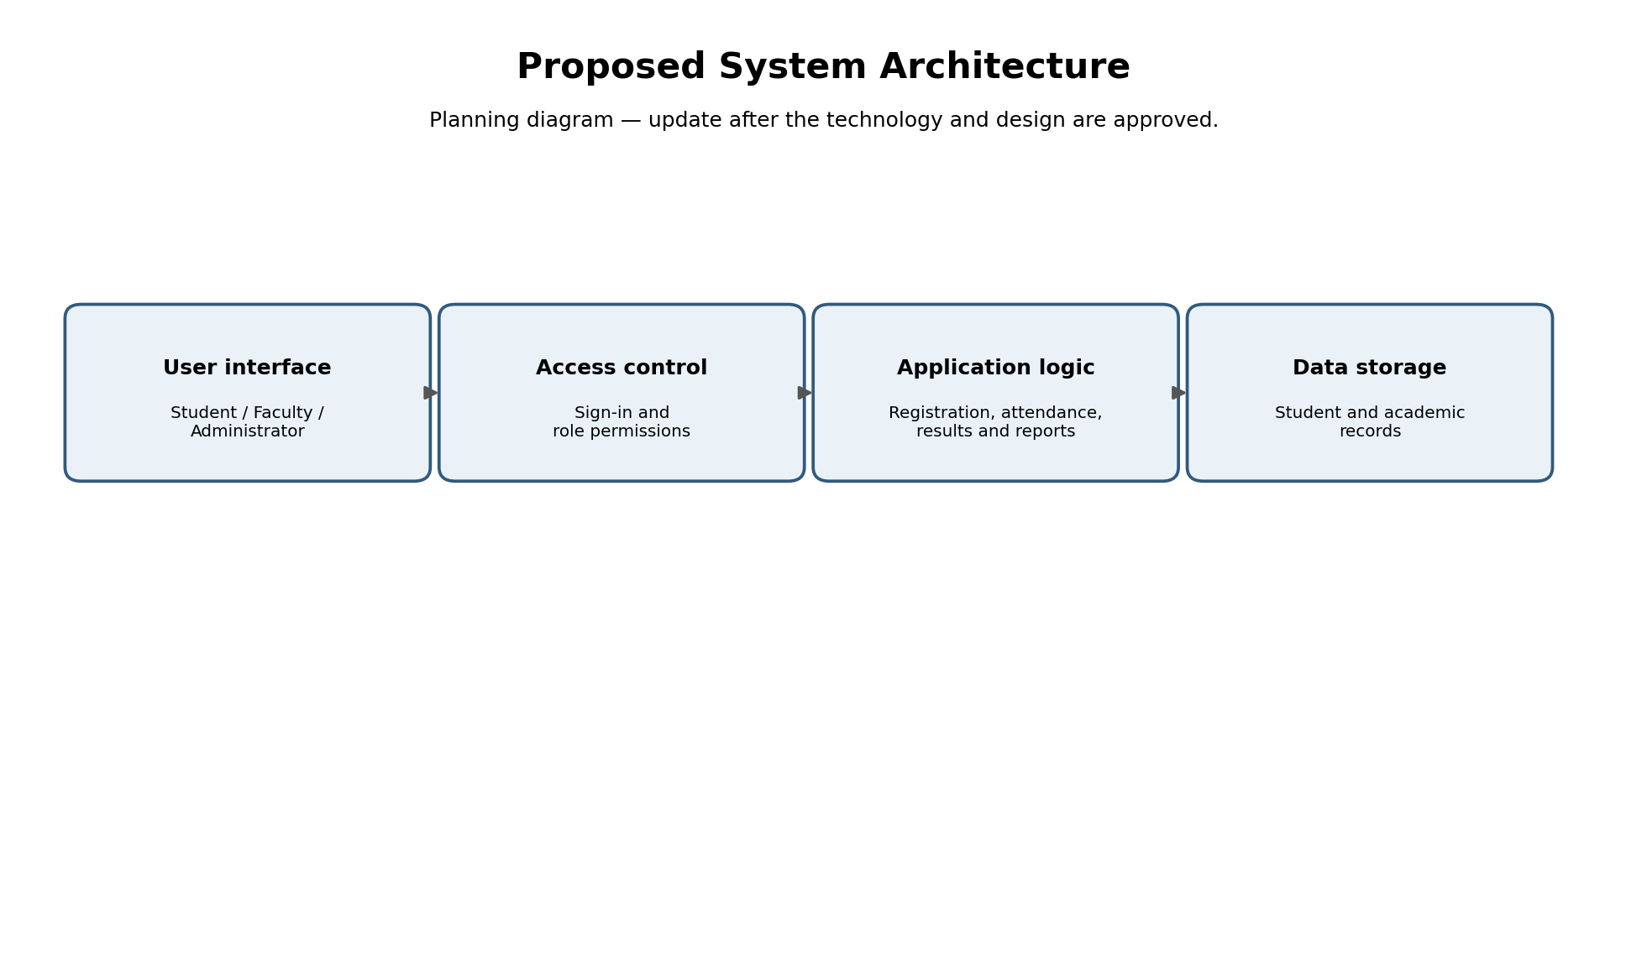

19.2 Project workflow
The project should move from understanding the problem to planning a solution, then building and testing it. If testing shows that a screen or process is confusing, revise it and test again rather than assuming the first design is correct.
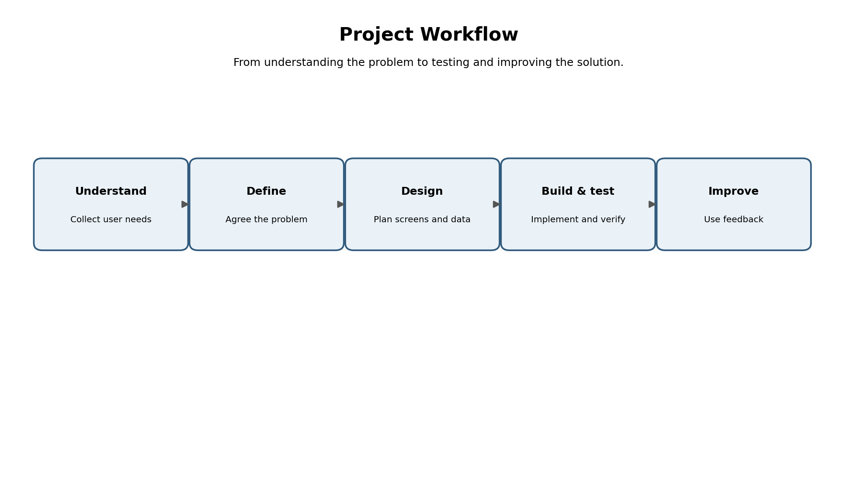

19.3 Design Thinking / IBM Loop visual
Use the loop to keep the work grounded in user feedback. For example, observe that a user struggles to find a student's record, reflect on whether the search or labels are unclear, make a small change, and review whether the task becomes easier.
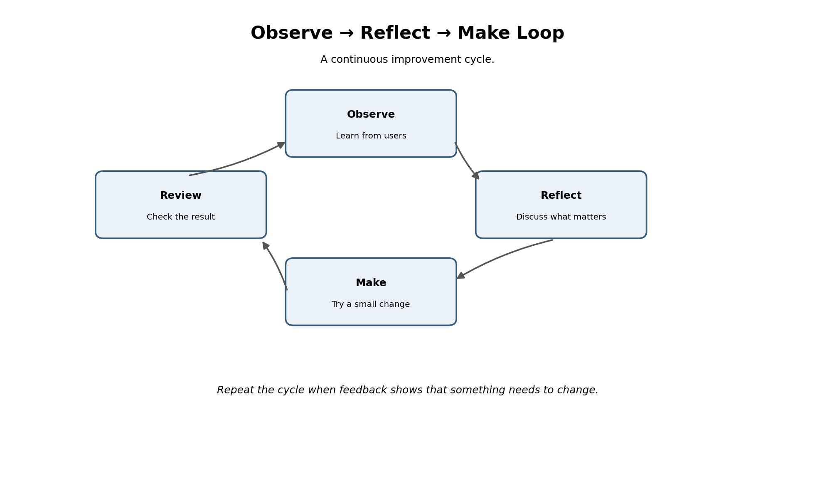

19.4 Project folder structure
The current GitHub repository is organized by course unit. Keep that structure because it matches the work already started. Store Unit 1's written deliverables under unit-1/docs/ so they are easy to find. Add application and DevOps tool folders only when those activities begin and the trainer's requirements are confirmed.
DevOps-mini-projects/
├── .github/
│ └── workflows/ # CI/CD workflow files (add when required)
├── docs/
│ └── screenshots/ # Genuine screenshots/evidence
├── unit-1/
│ ├── docs/ # BRD, FRS, NFRS, personas, roadmap, charter
│ ├── diagrams/ # Architecture and workflow diagrams
│ └── README.md # Notes for Unit 1 (optional)
├── unit-2/ # Work and evidence for Unit 2
├── unit-3/ # Work and evidence for Unit 3
├── unit-4/ # Work and evidence for Unit 4
├── unit-5/ # Work and evidence for Unit 5
├── .gitignore
└── README.md # Project overview (complete at the end)
Note: This is the recommended target structure. Some nested folders (such as unit-1/docs and unit-1/diagrams) may not exist in GitHub yet. Empty folders are not tracked by Git, so add a file inside each folder when you create it. Do not move or rename the existing repository folders without checking the current files first.

19.5 Folder purpose
Folder / file | What belongs here
.github/workflows/ | Automated build/test/deploy workflow YAML files when CI/CD is introduced.
docs/screenshots/ | Screenshots of real commands, repository state, diagrams, and completed practical tasks.
unit-1/docs/ | Unit 1 written reports: BRD, Product Vision, stakeholder analysis, personas, FRS, NFRS, Design Thinking, IBM Loop, MVP, roadmap, and charter.
unit-1/diagrams/ | Architecture, workflow, and design diagrams created for this project.
unit-2/ through unit-5/ | Separate deliverables and evidence for each course unit, following the trainer's instructions.
.gitignore | Rules for excluding secrets, temporary files, caches, and local-only configuration.
README.md | A project overview and setup guide; complete it after the scope and implementation are confirmed.

19.6 Suggested Git commands for creating the new folders
Run these in PowerShell from the existing repository folder. They create the recommended Unit 1 subfolders and keep evidence organized.
New-Item -ItemType Directory -Force unit-1\docs, unit-1\diagrams
Copy-Item .\student_platform_architecture.png .\unit-1\diagrams\
Copy-Item .\student_platform_workflow.png .\unit-1\diagrams\
Copy-Item .\design_thinking_cycle.png .\unit-1\diagrams\
git status
The three image files are included with this revised Word file only if you choose to save them separately from this chat. After copying them into your repository, check git status. Then stage and commit only the files you intend to submit.

20. Human review before submission
- ☐ Read each section and change any wording that does not match what you actually did or observed.
- ☐ Do not say that users were interviewed or prototypes were tested unless you really performed those activities.
- ☐ Add the names/dates and evidence requested by your instructor.
- ☐ Confirm whether the project topic is Student Record Management or Library Management before final submission.
- ☐ Ask your trainer whether the full Unit 1 deliverables should be one combined Word file or separate files.

